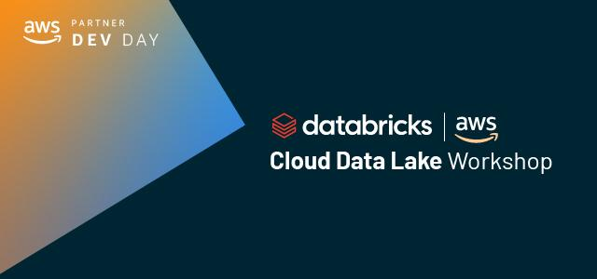

For this Cloud Data Lake Workshop, you can follow along with your Databricks Solution Architect. You can run the notebooks available in the zip file, which you have received in your remind email, on your own after the workshop by using Databricks.

The notebooks can also be downloaded from these url’s.

|  |  |  |
| --- | --- | --- |
| **Notebook** | **url** | **Type** |
| 00 - AWS CDL Devdays - Main notebook | https://dbricks.co/aws-cdl-devdays-00 | html |
| 01 - AWS CDL Devdays - CleanUp | https://dbricks.co/aws-cdl-devdays-01 | html |
| 02 - AWS CDL Devdays - Kinesis Stream Producer folder | https://dbricks.co/aws-cdl-devdays-02 | zip |
| 03 - AWS CDL Devdays - Prepare Bronze and Silver Clicks data | https://dbricks.co/aws-cdl-devdays-03 | html |
| 04 - AWS CDL Devdays - Spark to Athena | https://dbricks.co/aws-cdl-devdays-04 | html |
| 05 - AWS CDL Devdays - Push the Gold data to Redshift | https://dbricks.co/aws-cdl-devdays-05 | html |
| All Notebooks in DBC format | https://dbricks.co/aws-cdl-devdays-dbc-06 | dbc |

If you do not have a Databricks account, you can get your own free Databricks Community Edition (DBCE) account by going to <http://databricks.com/try-databricks>. Choose “**Community Edition**” (as illustrated in RED on the right).

Review the [Introduction to Apache Spark](https://docs.databricks.com/getting-started/spark/index.html) and the corresponding sample notebooks available from the Databricks documentation.